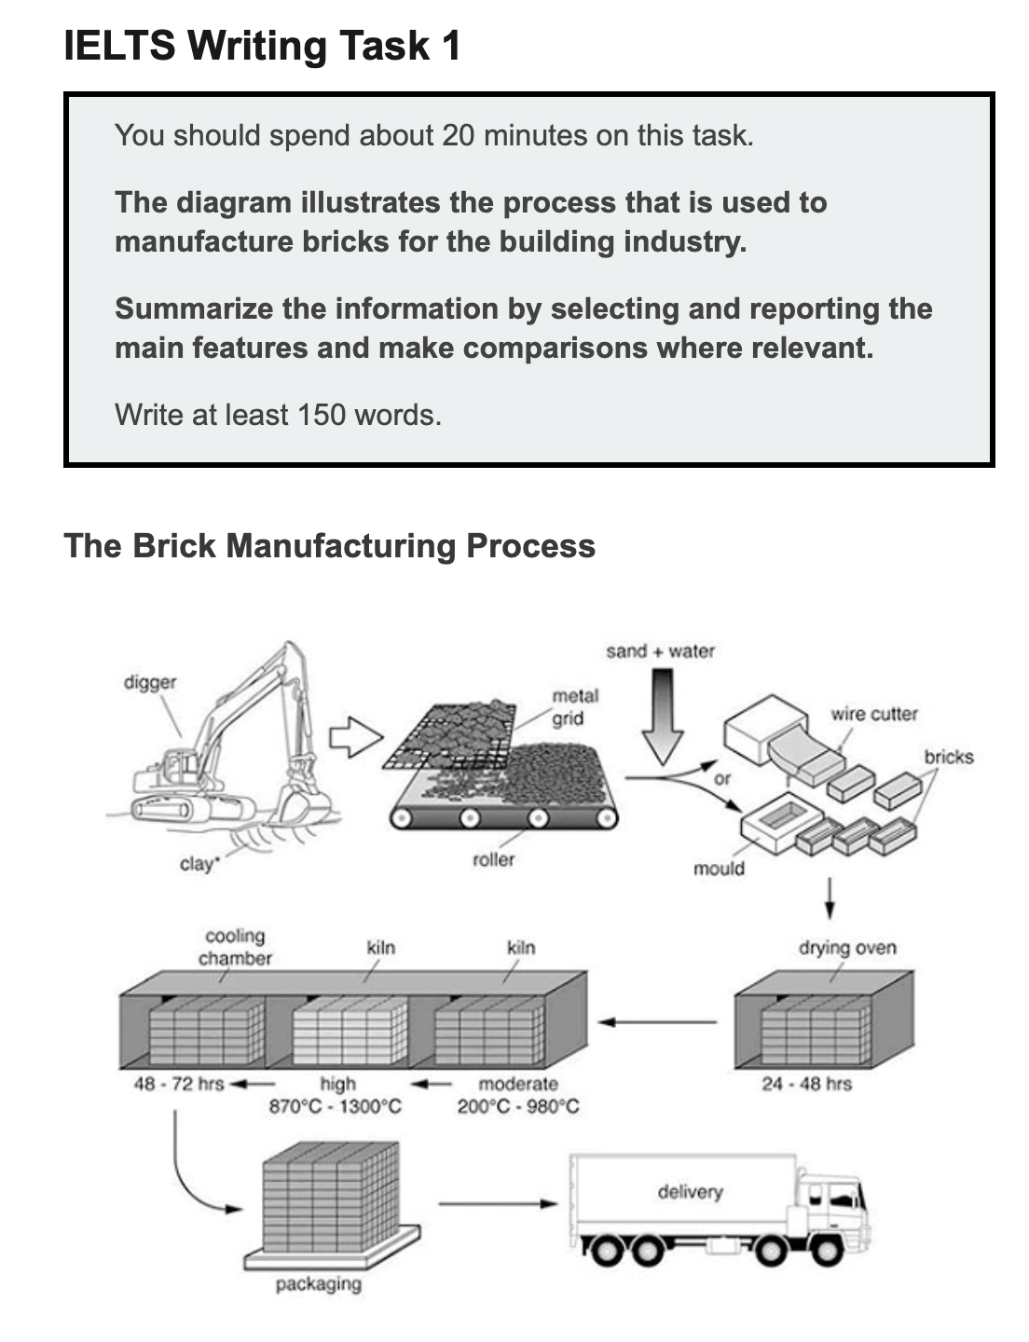

The diagram illustrates the process by which bricks are manufactured for the building industry.

Overall, there are seven stages, from digging clay up, through shaping the clay into bricks, drying, heating and cooling the bricks, to transporting the bricks.

First of all, clay is dug up from the ground by a large digger. Then, the clay is placed onto a metal grid to be broken up into smaller pieces that are transferred by a roller. Following this, sand and water are added to the clay to become mixture, and this mixture is turned into bricks by either placing it into a mould or using a wire cutter. Next, these bricks are placed in an oven to dry for 24 – 48 hours.

In the subsequent stage, the bricks go through a heating and cooling process. They are heated in a kiln at a moderate and then a high temperature (ranging from 200℃ to 1300℃), followed by a cooling process in a chamber for 2 – 3 days. Finally, the bricks are packed and delivered to their destinations.

(~175 words)

